**GRAPHIC DESIGN ASSIGNMENT**

Identify 3 good designs and 3 bad designs and in each give 3reasons.

**Good designs**



**Reasons.**

* The message is well elaborated and clear.
* The picture rhyme with the message.
* The picture and the message are convincing.



**Reasons.**

* The color is appealing.
* The message is simple.
* The subject matter being advertised is attractive.



**Reasons**

* The title is bold to show emphasis.
* Availability of the picture to support the heading.
* It further more gives the location and contacts on where to find them.

**Bad designs.**



Reasons.

* It is not emphasizing the important message.
* The message is not well organized.
* Not attractive.



**Reasons.**

* Message not clear.
* Not accessible.
* Not appealing.

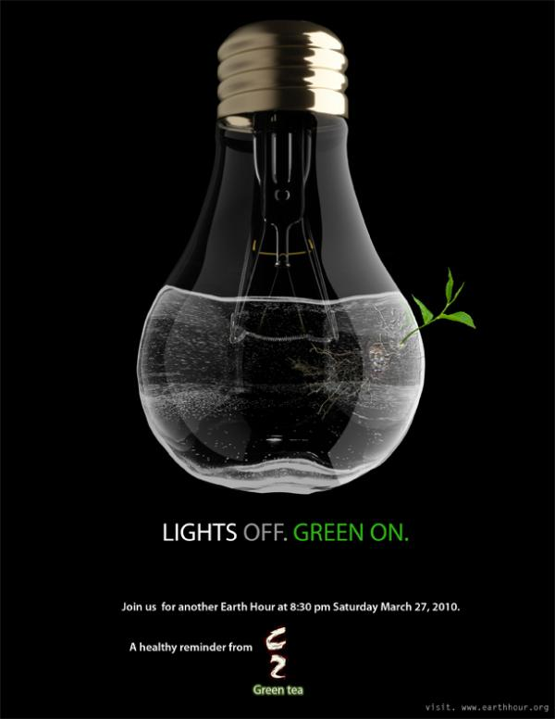

**REASONS.**

* Message not clear.
* Not appealing.
* No creativity.